In the programming world, there are [many languages](https://scand.com/company/blog/top-programming-languages-2019/), frameworks, and libraries used by developers for different purposes. But when it comes to .NET and Java, these two go hand in hand, quite often performing similar functions. That is why a comparison of Java and .NET is quite common.

This blog post aims at showing you the difference between Java and .NET, highlighting key features of each technology and answering the question: which one is better, Java or .NET. Also make sure to read our blog post on [Java vs PHP](https://scand.com/company/blog/php-vs-java-difference-comparison/).

Is .NET Similar to Java?

Since both .NET and Java can be used for the accomplishment of the same development goals, there is often a misconception in defining their technological identities. While both of them are often labeled as programming languages, only Java falls into this category. As for .NET, it is a framework in a classic sense, originally designed as a compilation of VB.NET and C#. To be exact, C# — the basis of .NET, was created to compete with Java that was considered as a top language for [mobile app development](https://scand.com/services/mobile-app-development/) of that time. Considering this fact, there is no wonder why today the difference between Java and .NET is widely discussed.

To find out if .NET is better than Java or vice versa, let’s take a look at the detailed comparison of both.

Comparison Between Java and .NET: Distinctions and Similarities

So what is the difference between Java and .NET? To answer this question, we’ll point out both the similarities and differences of these technologies.

.NET vs Java: Similarities

* **Both Java and .NET are object-oriented**: provide the ability to use classes.
* **Ensure code modularity**: allow taking classes from one project to use them with another.
* **Speed up the development**: support downloading and installing external dependencies from other coders into your project.
* **Fit different platforms**: web, desktop, and mobile.
* **Similar syntax**: both Java and .NET(C#) were made on the basis of C and C++.
* **Deployment restrictions**: to avoid runtime errors, both technologies require checking array indexes and variable initialization.
* **Both were created for heavy lifting**: perfect enterprise-level technologies, working with high-load systems, complex architectures, and big data applications.

Java and .NET Comparison: Differences

While Java over .NET comparison can take dozens of pages, the illustration below shows their key distinctions in services and features.

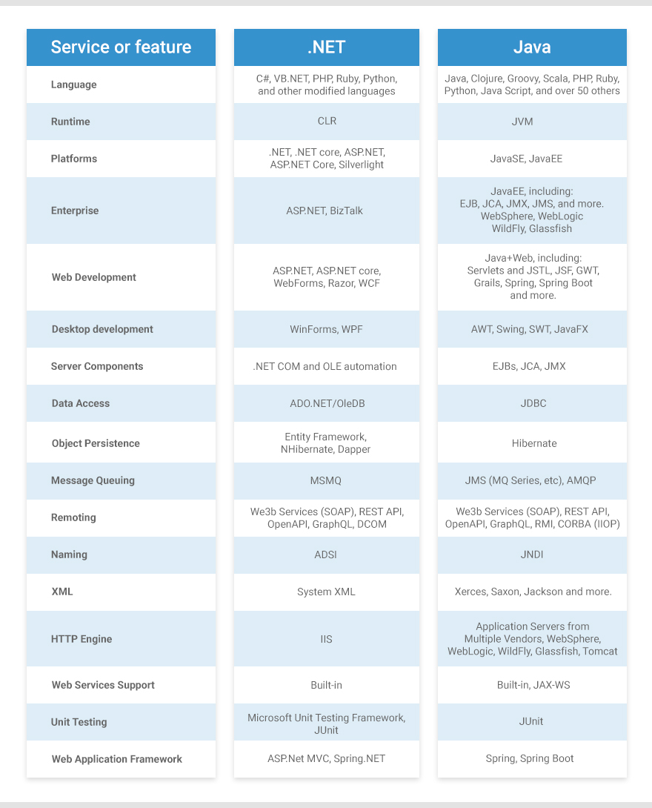

Java vs .NET: Which Is Better?

After we reviewed the differences and similarities of two technologies, it is time to find out which is best, .NET or Java. As there is no better way to trace the benefits and drawbacks of using programming technologies than considering arguments of those who work with them every day, let’s take a look at what developers say about Java and .NET.

Advantages of Java over .NET

Is Java better than .NET? Let’s try to answer this question, overviewing top Java over .NET advantages pointed out by developers:

* Java is free and open-source.
* It has a wider community of developers and, as a result, more support forums, and more documentation.
* Java offers more plugins in IDE’s, saving a lot of time in development.
* JVM (Java, Scala, Clojure, etc.) is much better implemented across several systems.
* Java’s exceptions are more controllable.
* Java goes toe to toe with IoT, offering vast libraries for [embedded apps development](https://scand.com/services/embedded-software-development/).
* Having a mature and strict structure and executing run-time checks, Java is ideal for the creation of error-free [enterprise software development](https://scand.com/expertise/custom-erp-software-development/).

Advantages of .NET over Java

Why .NET is Better Than Java and is it better at all? Let’s see what developers say when comparing Java and .NET.

* .NET is perfect for the development of Windows-specific platforms.
* Allows developers utilizing different languages (C#, VB.NET, C++) work together on the same project.
* .NET offers effortless debugging.
* Deployment of applications developed with .NET is fast and easy.
* Ajax implementation is simple and easy.
* .NET is great at building UIs.
* Microsoft offers Azure for cloud IoT and Big Data.

Finally, Which is Best, .NET or Java?

The truth is that both technologies — Java and .NET — are very similar at a language level. What is more, both are much alike in terms of speed, memory, programming efficiency, available libraries, etc. So when it comes to answering the question on what is the difference between Java and .NET, the answer mainly depends on a project.